Lesson 02 Demo 01

Creating Static Host Inventory

Objective: To create a static host inventory for managing and automating infrastructure tasks efficiently across multiple servers using Ansible

Tools required: Ubuntu OS

Prerequisites: You need to have Ansible installed to proceed with this demo

Steps to be followed:
- Generate SSH key pair on the main node
- Copy the SSH key to the two other nodes
- Update the inventory or host file with the host IP address
- Establish connectivity between the hosts specified in the host file and the Ansible server

Step 1: Generate SSH key pair on the main node

- Use the following command to generate the SSH key on the Ansible server:
ssh-keygen
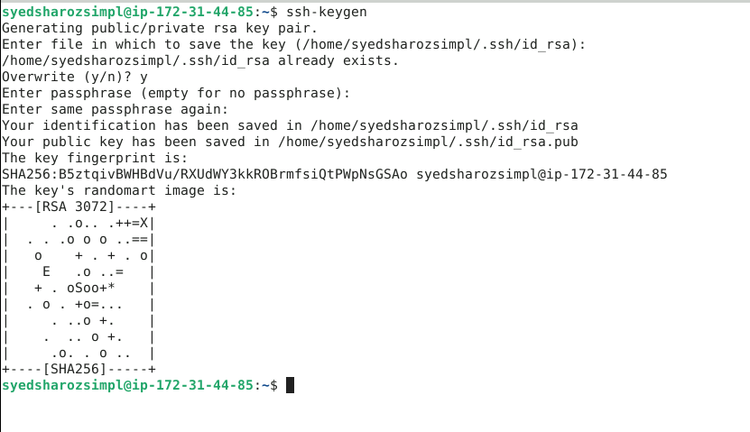

Step 2: Copy the SSH key to the other two nodes

  - Use the following command to copy the public key to a file named authorized_keys
in localhost:
cat .ssh/id_rsa.pub >> .ssh/authorized_keys

  - Run the following command to go to the .ssh directory of the Ansible server:
cd .ssh

  - Run the following command to copy the public key to another node that will connect to the Ansible server:
ssh-copy-id labuser@IP

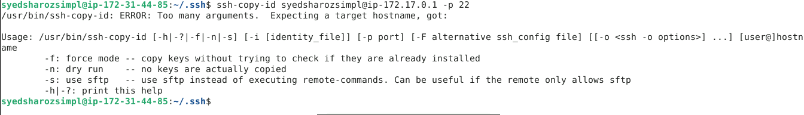

Note: You must use a username@ip with your node and IP username, which are provided in the lab credential.

  - Execute the following command to exit the .ssh directory of the Ansible server:
cd ..

Step 3: Update the inventory or host file with the host IP address

  - Use the following command to open the Ansible inventory file and add the host localhost to it:
sudo vi /etc/ansible/hosts



  - When the file opens, add the three lines of code below to the end of the file:
[dbservers]
localhost

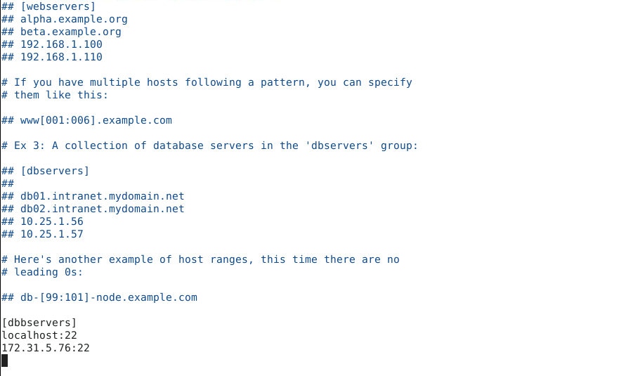
Note: Press esc, then write :wq and press enter to save the file.

Step 4: Establish connectivity between the hosts specified in the host file and
the Ansible server

  - Run the following command to copy the public key to another node that will connect to the Ansible server:
ansible -m ping dbservers

  - Use the following command to check the number of hosts in the host file:
ansible all --list-hosts

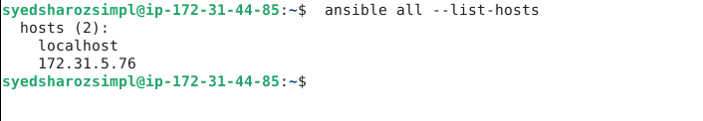

By following these steps, you have successfully created a static host inventory for managing and automating infrastructure tasks efficiently across multiple servers using Ansible.

